Ideation Phase

Brainstorm & Idea Prioritization Template

Date | [Insert Submission Date]
Team ID | [Insert Team ID]
Project Name | Strategic Product Placement Analysis
Maximum Marks | 4 Marks

Brainstorm & Idea Prioritization Template:
Brainstorming provides a free and open environment that encourages everyone within a team to participate in the creative thinking process that leads to problem solving. Prioritizing volume over value, out-of-the-box ideas are welcome and built upon, and all participants are encouraged to collaborate, helping each other develop a rich amount of creative solutions.
This document applies the template to our project, Strategic Product Placement Analysis, which investigates the relationship between product positioning, sales performance, and consumer behavior. Using Tableau, the team analyzes retail sales, placement, and demographic data to uncover which positioning strategies drive revenue, and translates those findings into actionable recommendations for the retail company.
Reference: https://www.mural.co/templates/brainstorm-and-idea-prioritization

Step 1: Team Gathering, Collaboration and Select the Problem Statement

Context
A retail company has collected data on sales figures, product placement, and consumer demographics. It wants to understand which product positioning strategies are most effective at driving sales, and how marketing and merchandising efforts can be tailored accordingly. The team gathered to align on goals, review the available data, and frame the core problem before brainstorming solutions.

Problem Statement (How Might We)
How might we use data visualization and analytics in Tableau to identify the product positioning strategies that most effectively drive sales performance and align with consumer preferences, so the retail company can optimize shelf/placement decisions and increase revenue?

Key Rules of Brainstorming Followed
- Stay on topic
- Defer judgment
- Go for volume
- Encourage wild ideas
- Listen to others

- Be visual where possible

Step 2: Brainstorm, Idea Listing and Grouping
Every idea that could address the problem statement was written down without filtering, then similar ideas were clustered into themed groups.

Raw Brainstormed Ideas
- Compare sales performance of eye-level vs. top/bottom shelf placements
- Analyze the impact of end-cap and promotional displays on impulse purchases
- Segment consumers by age, gender, and income to identify placement preferences
- Build Tableau heat maps correlating store layout zones with sales density
- Study the effect of checkout-aisle placement on add-on sales
- Evaluate cross-category placement and complementary product bundling
- Track seasonal/promotional placement shifts and their impact on sales
- Analyze online marketplace placement (search ranking, sponsored slots) vs. sales
- Correlate foot-traffic data with placement zones using Tableau dashboards
- Survey consumers on visibility and ease-of-find as purchase drivers
- Build a predictive model linking placement variables to revenue
- Design an interactive Tableau dashboard so category managers can simulate placement changes

Grouped Idea Clusters

Cluster | Ideas Included
A. In-Store Placement Strategies | Eye-level vs. shelf placement; end-cap & promo displays; checkout-aisle placement; cross-category bundling; seasonal placement shifts
B. Consumer Behavior & Segmentation | Demographic segmentation (age/gender/income); visibility & ease-of-find survey
C. Data Visualization & Analytics (Tableau) | Heat maps of store zones vs. sales; foot-traffic correlation dashboards; online marketplace placement analysis; predictive placement-to-revenue model; interactive manager dashboard

Step 3: Idea Prioritization
Ideas were plotted on an Importance vs. Feasibility grid so the team can agree on what to tackle first. Ideas in the top-right quadrant (high importance, high feasibility) are prioritized for the current project phase.
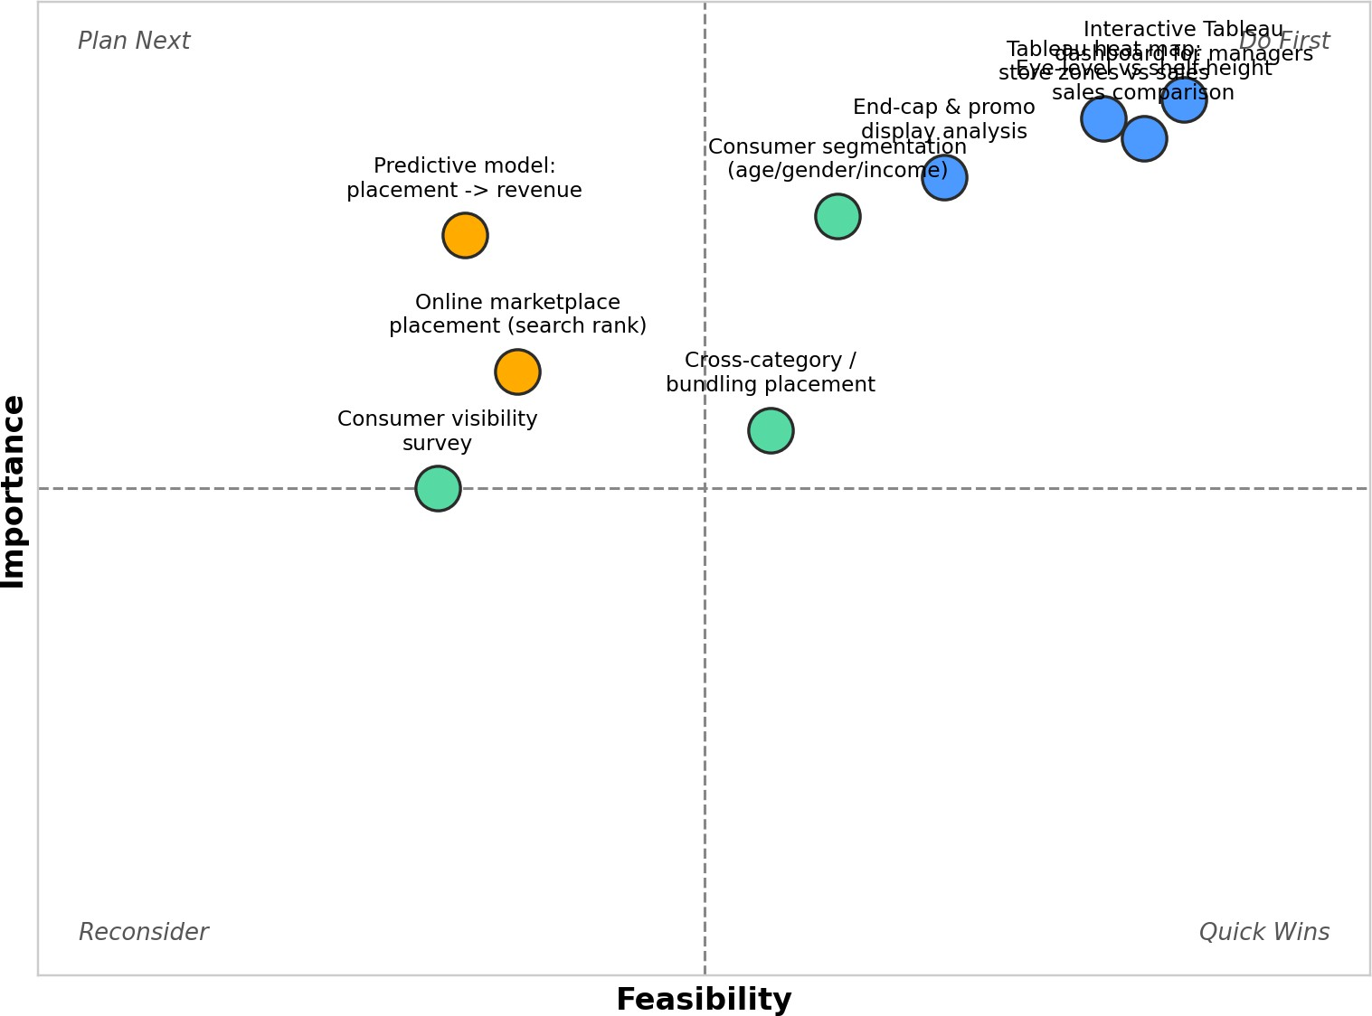

Prioritized Focus (Do First)
- Interactive Tableau dashboard for category managers
- Tableau heat map of store zones vs. sales
- Eye-level vs. shelf-height sales comparison

Deferred / Lower Priority
- Predictive placement-to-revenue model (high value but time/complexity constrained)
- Online marketplace placement analysis (limited data access)
- Consumer visibility survey (time-intensive relative to impact)

